Validation of PIF files


Date: 23rd April 2013

Copyright Notice
This document contains proprietary information of HCL Technologies Ltd. No part of this document may be reproduced, stored, copied, or transmitted in any form or by means of electronic, mechanical, photocopying or otherwise, without the express consent of HCL Technologies. This document is intended for internal circulation only and not meant for external distribution.

Table of Contents

1. INTRODUCTION 3
2. ABOUT SCORM CLOUD TOOL 3
3. BRIEF INTRODUCTION OF PIF Files 4
4. APPENDIX 5
5. LIST OF ROOT SCOs AVAILABLE IN PRODUCTION 11

INTRODUCTION

During the process of the SCO Deployment the PIF Files are deleted from the backend because the deployed changes don’t get updated in existing PIF files automatically. So there is a risk that the user could use the existing PIF files which are not updated and are not in sync with the newly deployed SCOs.
To avoid that risk PIF files need to be validated just to confirm that the newly created PIF files are working as expected and have all the updates.

ABOUT SCORM CLOUD TOOL

SCORM Cloud tool is a simple way to deliver e-learning to learners. The Dispatch feature of SCORM Cloud is to maintain control over your content even after it has been delivered to an LMS.

A Dispatch Package is a shell of a SCORM package that can be imported into an LMS. When the shell is launched by an LMS, SCORM Cloud loads your course inside the shell. This gives you a new level of control over your content — a level not available from a traditional LMS alone.
Dispatch Packages report high-level results to the LMS and keeps detailed results in SCORM Cloud, even though your course technically stays on SCORM Cloud servers.

It is a popular open-source LMS, but it doesn’t support SCORM 2004.

BRIEF INTRODUCTION OF PIF Files

PIF file is SCORM compliant and is used in LMS Platform. It is used as an input in Realize Platform.PIF Files contains SCORM artifacts (bunches of XSDs), SCO files and Manifest file which is created at run time. To check whether PIF file is 100% compliant or not we use SCORM cloud tool.

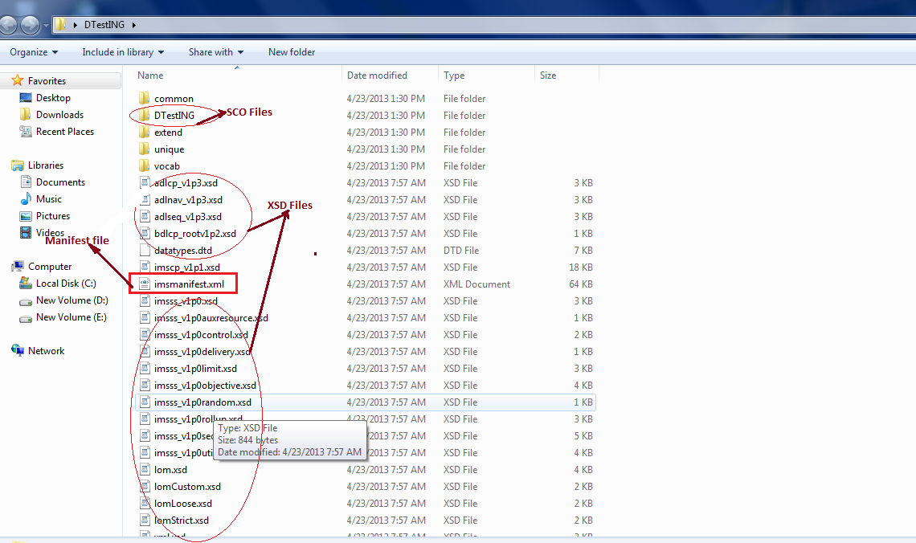

APPENDIX

PIF Files can be validated with the following steps:
- Create Authored SCO:
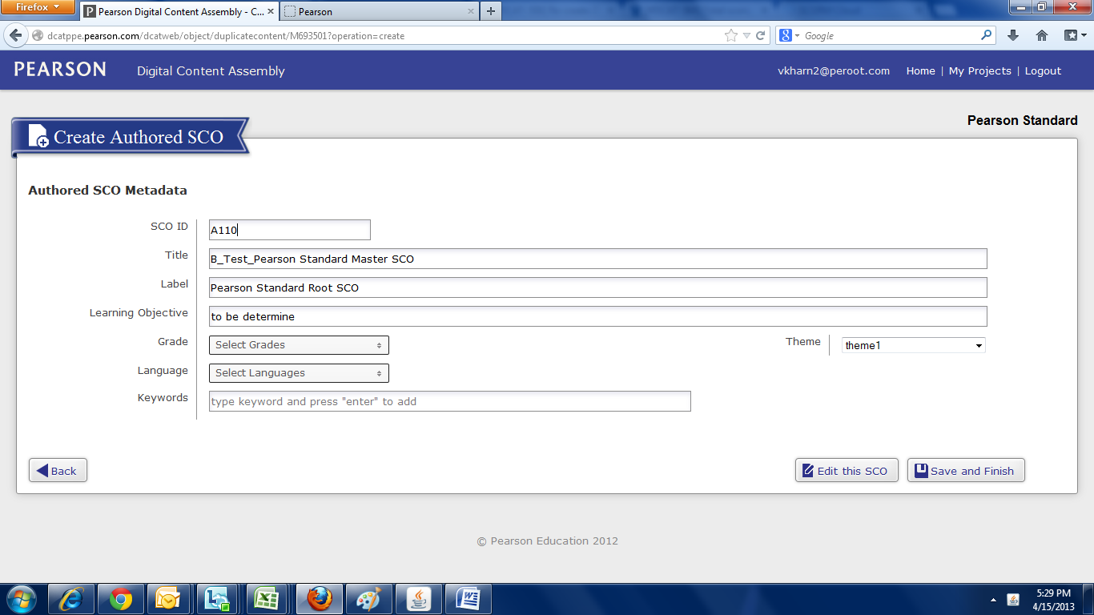
- Change state of the created SCO to “Published” or “Ready for Publishing”:
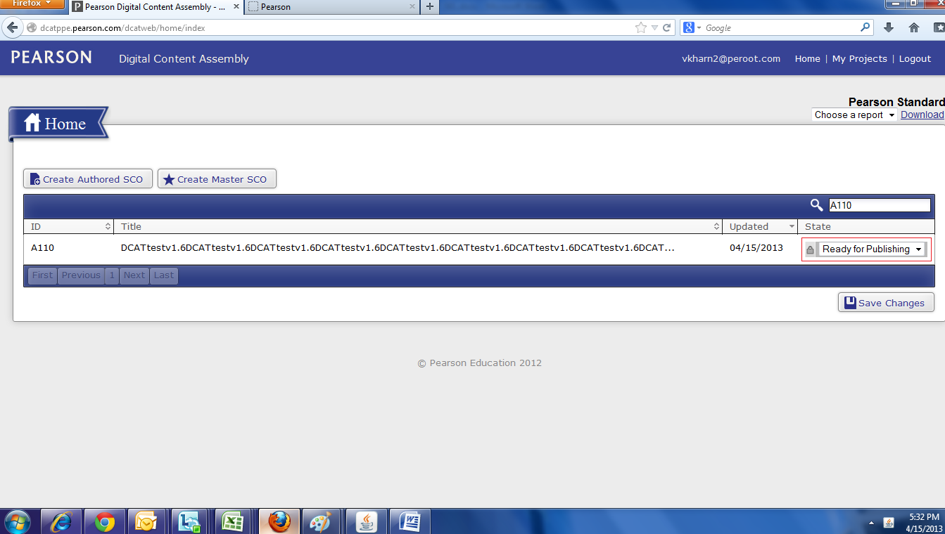

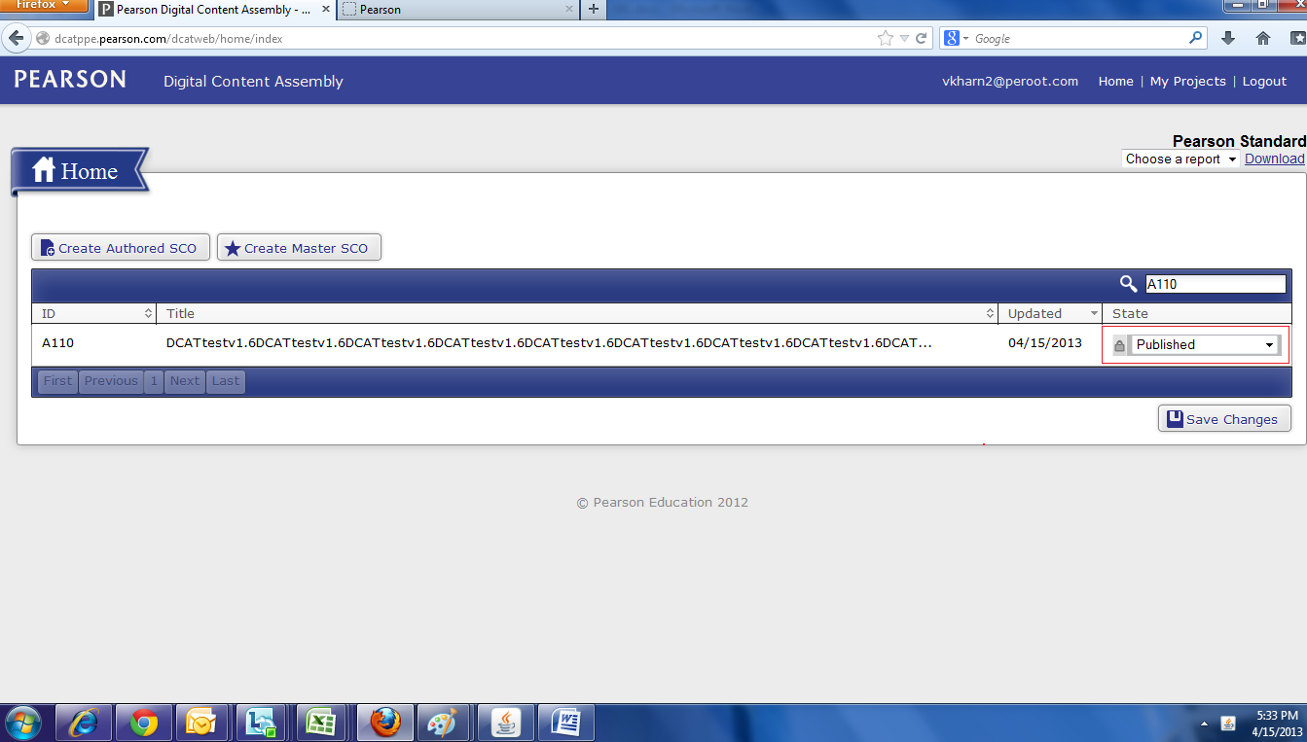
- Generate PIF Report from Home screen:
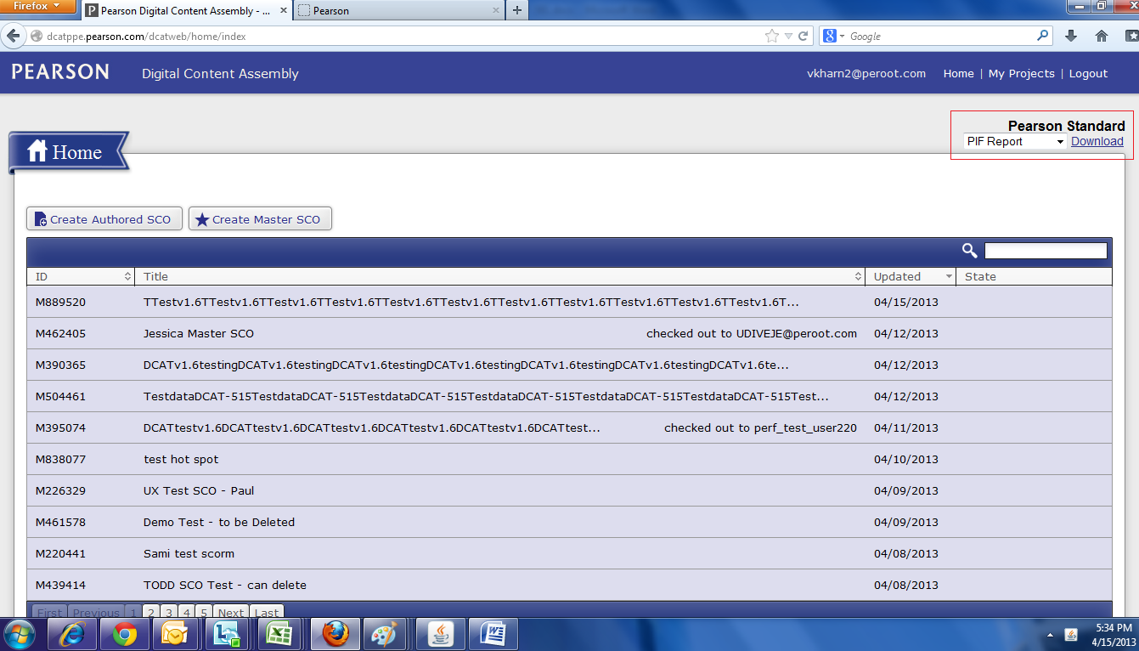

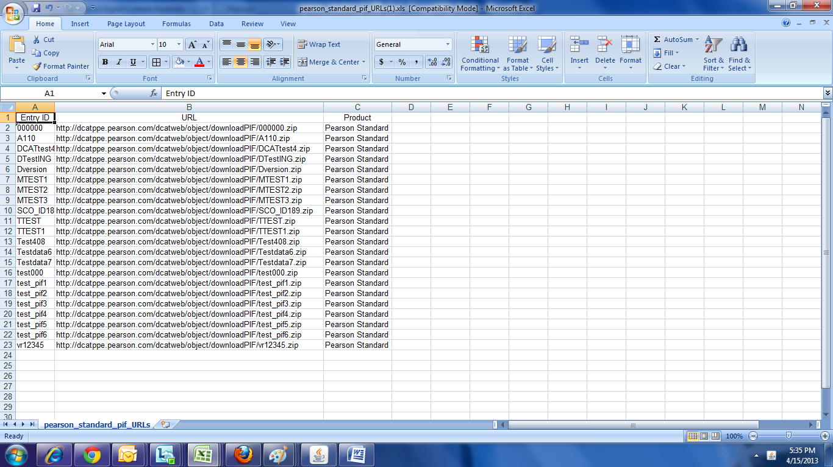

- Download PIF SCO on your Local from the generated PIF reports:

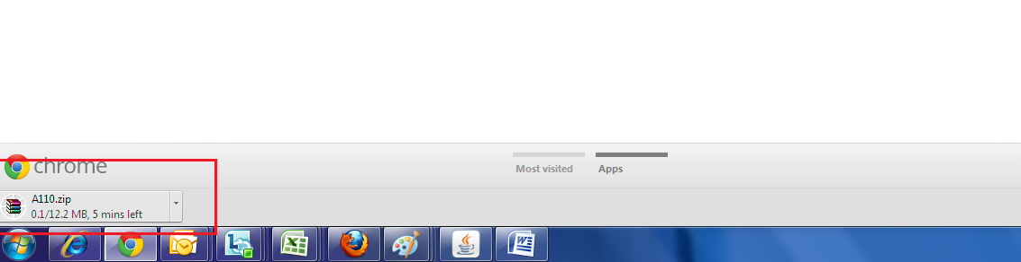

- Open SCORM Cloud Tool:
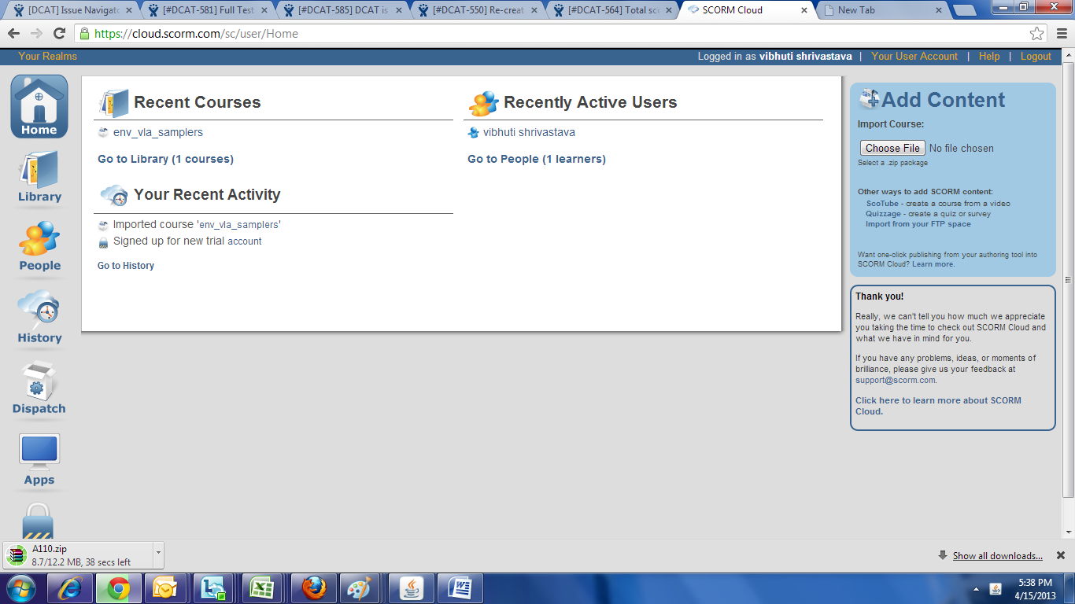

- Upload PIF File from Choose File button:
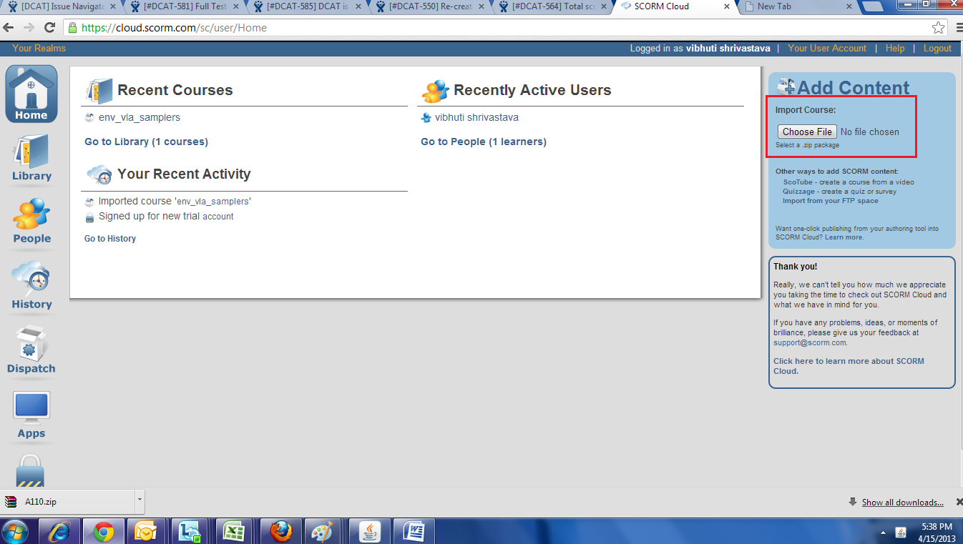

- If PIF file is correct then user will get a successful message “Congratulation your manifest looks great
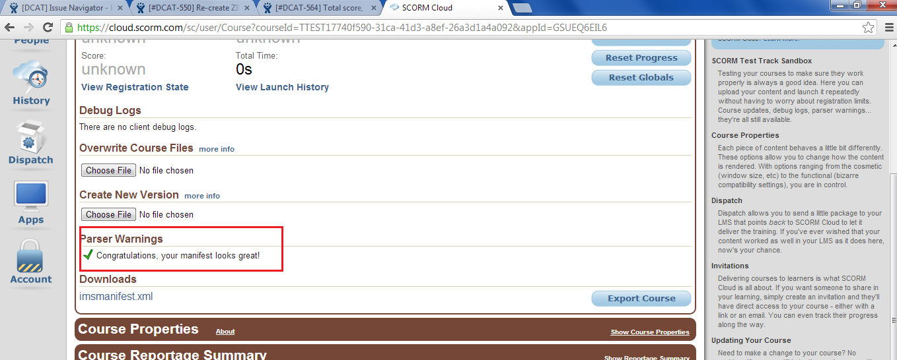

- User can see imported course in Library tab
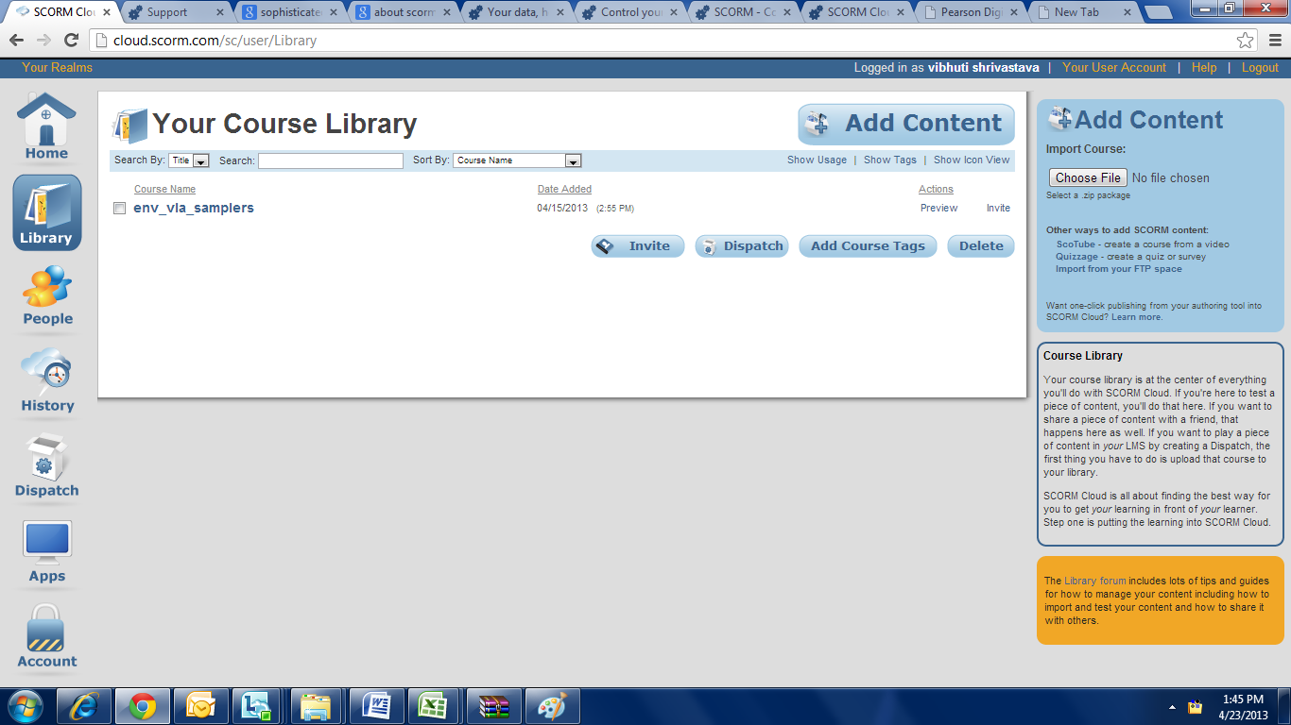
Select course and click on Preview link and imported course is launched in a new window
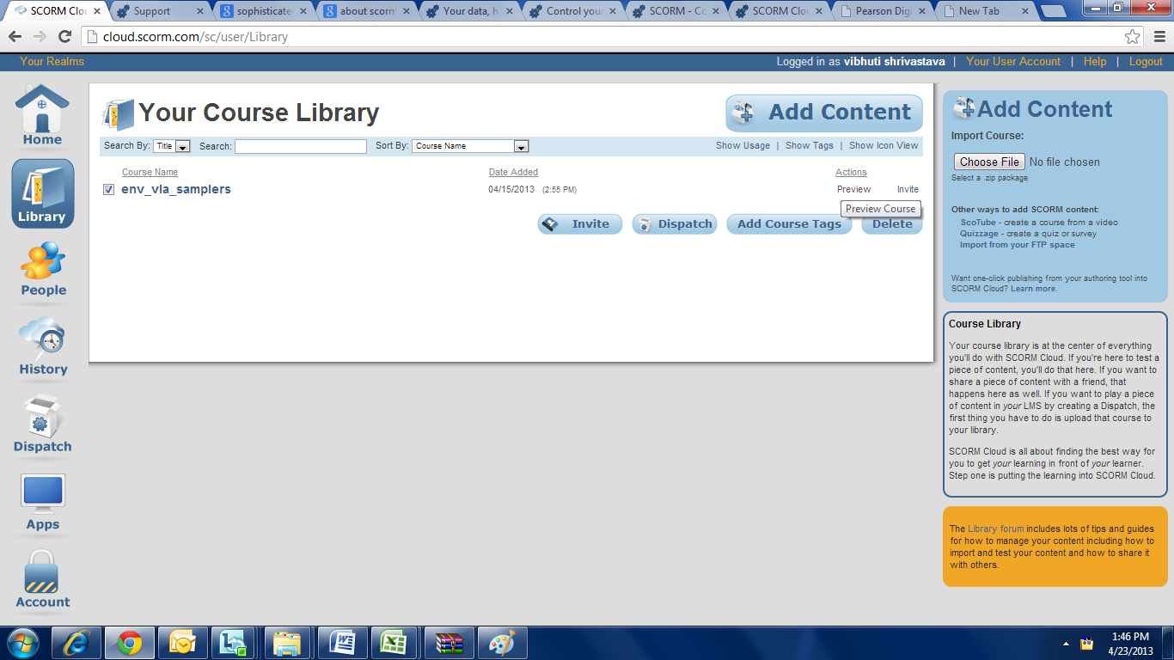

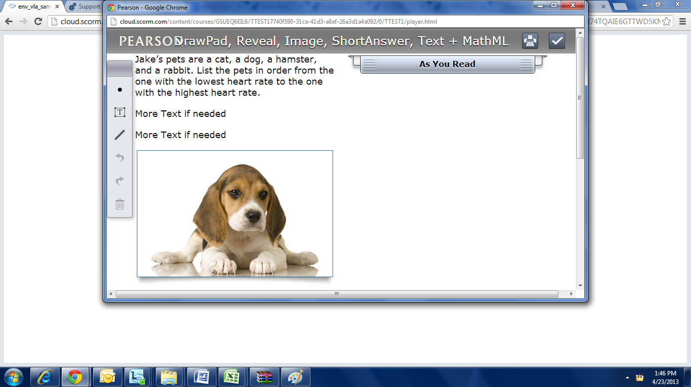

LIST OF ROOT SCOs AVAILABLE IN PRODUCTION

Program Name | Root SCO Title
CMP3 | Glossary
CMP3 | Dash
DASH Standard | Dash
DASH Standard | Glossary
Digits TX | Dash
Digits TX | Glossary
K12 TX Science Elementary | Middle Grade Science Glossary Root SCO
K12 TX Science Elementary | Texas K-12 Science Root SCO
K12 TX Science High School Biology | Texas K-12 Science Root SCO
K12 TX Science High School Biology | Middle Grade Science Glossary Root SCO
K12 TX Science High School Chemistry | Texas K-12 Science Root SCO
K12 TX Science High School Chemistry | Middle Grade Science Glossary Root SCO
K12 TX Science Middle Grades | Middle Grade Science Glossary Root SCO
K12 TX Science Middle Grades | Texas K-12 Science Root SCO
LIT 1.5 | PH Literature
MD_Online_Modules | MD Online Root SCO
NGSS_HSUS | Glossary SCO
NGSS_HSUS | Next Generation Social Studies
NGSS_HS_SKILLS | Glossary SCO
NGSS_HS_SKILLS | Next Generation Social Studies
NGSS_ISSUES_EVENTS | Next Generation Social Studies
NGSS_ISSUES_EVENTS | Glossary SCO
NGSS_MGAH | Next Generation Social Studies
NGSS_MGAH | Glossary SCO
NGSS_PRIMARY_SOURCES | Next Generation Social Studies
NGSS_PRIMARY_SOURCES | Glossary SCO
NGSS_SC_CASES | Next Generation Social Studies
NGSS_SC_CASES | Glossary SCO
Pearson Standard | Pearson Standard Root SCO
Pearson_Sandbox | Pearson Standard Root SCO
enVMath 2015 TX | Texas Envision Math Root SCO
enVMath 2015 TX | Texas Envision Math Glossary SCO
iBooks – Humanities | iBooks
iBooks – Literacy | iBooks

